# Chapter 1

## **Introduction**

#### **PURPOSE**

1.1.1 FINGPT FORCASTER FOR NSEI(NATIONAL STOCK EXCHANGE INDIA) COMPNIES

The purpose of this project is to address the need for stock price forecasting for companies listed on the National Stock Exchange of India (NSE) by leveraging news articles and sentiment analysis. While existing solutions cater to companies listed on NASDAQ, there is a lack of similar tools for NSE-listed companies.

By utilizing natural language processing (NLP) techniques and machine learning models, this project aims to analyze news headlines from the current date to one month ahead. This analysis will help predict potential stock price movements for NSE-listed companies.

The project's primary goal is to assist investors and financial analysts in making informed decisions. By providing insights into market sentiment and potential stock price trends, the application can help users adjust their investment strategies accordingly. This proactive approach to market analysis can lead to improved investment outcomes and better risk management.

Moreover, the project aims to democratize access to sophisticated financial analysis tools. By providing a user-friendly interface and actionable insights, the application can empower a broader range of investors, including individual traders and small-scale investors, to make data-driven investment decisions.

In summary, this project serves to fill a crucial gap in the financial market by offering stock price forecasting for NSE-listed companies. Through its innovative use of NLP and machine learning, the application aims to revolutionize how investors approach stock market analysis in the Indian context.

1.1.2 FACTS & STATISTICS

The forecasting application for companies listed on the National Stock Exchange of India (NSE) using news articles and sentiment analysis is a significant development in the Indian financial market. This project combines advanced natural language processing (NLP) techniques and machine learning models to analyze news headlines, providing insights into potential stock price movements for NSE-listed companies. By leveraging the unique dynamics of the Indian market, the application aims to enhance investment decision-making for a diverse range of stakeholders, including individual investors, traders, and financial analysts.

In terms of statistics, the project processes news articles from various sources to extract relevant information and sentiment. It utilizes sentiment analysis to gauge market sentiment and predict stock price trends. The application provides forecasts for a one-month period, allowing users to anticipate market movements and adjust their investment strategies accordingly. Additionally, the project offers a user-friendly interface, making it accessible to a wide audience interested in the Indian stock market.

Overall, this project represents a significant step forward in leveraging technology to enhance financial analysis and decision-making in the Indian context. By providing timely and accurate forecasts based on news sentiment, the application has the potential to revolutionize how investors approach the Indian stock market, ultimately leading to more informed and profitable investment decisions.

* 1. **TARGET CROWD**

The target audience for this project primarily consists of individual investors, financial analysts, and traders who are actively participating in the National Stock Exchange of India (NSE). These users are constantly seeking ways to make informed investment decisions in the Indian stock market, and this project aims to provide them with data-driven insights based on news sentiment analysis.

Individual investors are retail investors who invest their personal savings in the stock market. They often rely on news and social media to make investment decisions. This project can help them by providing a user-friendly interface to analyze news sentiment and make informed decisions.

Financial analysts are professionals who analyze financial data and provide recommendations to their clients. They can use this project to analyze news sentiment and make informed recommendations to their clients. The project's user-friendly interface makes it accessible to financial analysts who may not have advanced technical skills.

Traders are individuals or institutions that buy and sell securities in the financial markets. They use various strategies to make profits in the market. News sentiment analysis can be a valuable tool for traders to predict short-term price movements. This project can help traders by providing a user-friendly interface to analyze news sentiment and make informed decisions.

The National Stock Exchange of India (NSE) is the leading stock exchange in India, and it is essential for users interested in investing in the Indian stock market to stay updated with the latest news and trends. This project can help NSE users by providing data-driven insights based on news sentiment analysis.

The project's user-friendly interface is designed to cater to a wide range of users, including those who may not have advanced technical skills. The interface is easy to navigate, and users can quickly analyze news sentiment and make informed investment decisions. The project's focus on the Indian stock market makes it a valuable tool for users interested in making informed investment decisions in this market.

In summary, this project is designed for individual investors, financial analysts, and traders who are active in the National Stock Exchange of India. It provides data-driven insights based on news sentiment analysis, and its user-friendly interface makes it accessible to a wide range of users. By using this project, users can make informed investment decisions in the Indian stock market based on news sentiment analysis.

#### **OUTCOME ASPECTED**

To add a translation API for converting all other language headlines into English before performing sentiment analysis, you can use a translation API such as Google Translate API or Microsoft Azure Text Translation API. These APIs can be integrated into your existing code to translate the headlines into English before performing sentiment analysis.

To expand on the target audience for this project, the project is designed for individual investors, financial analysts, and traders who are active in the National Stock Exchange of India (NSE). These users are seeking data-driven insights into stock price movements based on news sentiment analysis. The project's user-friendly interface makes it accessible to a wide range of users interested in making informed investment decisions in the Indian stock market. By providing accurate and timely stock price forecasts based on news sentiment analysis, the project aims to help users make informed investment decisions, leading to improved investment outcomes and a better understanding of market trends in the Indian context.

To provide accurate and timely stock price forecasts based on news sentiment analysis, the project will analyze news articles from the current date to one month ahead. By analyzing news articles, the application aims to predict potential stock price movements and provide valuable insights for investors and financial analysts. The project's success will be measured by its ability to deliver reliable forecasts that help users make informed decisions, leading to improved investment outcomes and a better understanding of market trends in the Indian context. The project will use machine learning algorithms to analyze news articles and extract sentiment scores, which will be used to predict stock price movements. The project will also provide users with a user-friendly interface to access the forecasts and insights.

# Chapter 2

## **Composition Contemplate**

**2.1 FORMATION ANALYSIS**

The forecasting application for companies listed on the National Stock Exchange (NSE) of India is a sophisticated, multi-step process that leverages both historical stock price data and current news headlines to predict future stock prices. This approach provides valuable insights for investors and financial analysts, enabling them to make informed decisions based on data-driven predictions.

The process begins with the collection of news headlines related to the target companies from various sources, including news websites, financial blogs, and social media platforms. These headlines are then subjected to sentiment analysis using natural language processing (NLP) techniques. Sentiment analysis is a method of natural language processing that involves computationally identifying and categorizing opinions expressed in a piece of text, especially in order to determine whether the writer's attitude towards a particular topic, product, etc. is positive, negative, or neutral. By analyzing the sentiment of news headlines, the application is able to determine the overall market sentiment towards the target companies.

Simultaneously, historical stock price data for the target companies is fetched using the yfinance library, a powerful and easy-to-use library for downloading historical market data from Yahoo Finance. This data is then preprocessed, including scaling using sklearn's MinMaxScaler, a method used to transform features by scaling each feature to a given range, typically between zero and one. This is necessary to ensure that all features have the same scale, as neural networks are sensitive to the scale of input features.

Once the data is preprocessed, it is used to train an LSTM-based neural network model implemented using keras. Long Short-Term Memory (LSTM) is a type of recurrent neural network (RNN) capable of learning long-term dependencies, which makes it well-suited for time series prediction tasks such as stock price prediction. The model is trained on past stock price data and corresponding sentiment scores, enabling it to learn patterns and relationships between the two.

Finally, the trained model is used to predict future stock prices based on the sentiment of news headlines. This provides a powerful tool for investors and analysts, enabling them to anticipate market movements and make informed decisions based on data-driven predictions. By combining both historical stock price data and current news headlines, the forecasting application is able to provide a more comprehensive and accurate prediction of future stock prices.

#### **TECHNOLOGY USED**

1. Python is a high-level, interpreted programming language that may be used for a variety of tasks. Python was created by Guido van Rossum. The design philosophy of Python places an emphasis on the readability of its source code by making prominent use of substantial whitespace. Its language elements and object-oriented approach are designed to assist programmers in writing code that is both comprehensible and rational for projects of varying sizes. Python is a dynamically typed programming language that also supports a variety of programming paradigms. Procedural, object-oriented, and functional programming are examples of programming paradigms.
2. b. JUPYTER Lab is a non-profit organisation dedicated to providing open-standards, open-source software and services for interactive computing in a variety of programming languages.
3. c. GRADIO- Gradio is a Python library that simplifies the process of creating user interfaces for machine learning models. It allows you to quickly build interactive web-based interfaces for your models, without requiring any web development experience. Gradio supports a variety of input types, including text, images, and audio, making it versatile for different types of models. It also provides features for customizing the interface's appearance and behavior, such as sliders, checkboxes, and dropdowns. Gradio is useful for showcasing your models, enabling others to interact with them easily, and gaining insights into model behavior through user interactions.

# NEWSAPI - The News API is a web service that provides access to a large collection of news articles from around the world. It allows developers to fetch news headlines, articles, and other content from a variety of sources and categories. The News API offers endpoints for searching and retrieving news articles based on keywords, sources, language, and other parameters. Developers can use the News API to integrate news content into their applications, websites, or services. It provides a convenient way to access up-to-date news information, making it useful for a wide range of applications, including news aggregators, content curation platforms, and data analysis tools.

# YAHOO! FINANCE- Yahoo Finance is a popular financial website that provides a wide range of financial information, including stock quotes, news, analysis, and financial tools. The Yahoo Finance API, also known as Yahoo Finance API, is a programming interface that allows developers to access and integrate Yahoo Finance data into their own applications.With the Yahoo Finance API, developers can fetch historical stock price data, current stock quotes, company information, financial statements, and more. This data can be used to build financial analysis tools, stock market trackers, and other financial applications.The Yahoo Finance API is widely used by developers, traders, and financial analysts to access and analyze financial data from Yahoo Finance. However, it's important to note that the availability and terms of use of the Yahoo Finance API may vary, so developers should review the API documentation and terms of use before integrating it into their applications.Developers can use the News API to integrate news content into their applications, websites, or services. It provides a convenient way to access up-to-date news information, making it useful for a wide range of applications, including news aggregators, content curation platforms, and data analysis tools.

# FINGPT- It seems there might be a typo in your query. If you meant to ask about "FINBERT," it's a pre-trained NLP model specifically designed for financial sentiment analysis. FINBERT is based on the BERT (Bidirectional Encoder Representations from Transformers) architecture and is fine-tuned on financial text data to perform tasks like sentiment analysis, classification, and other financial NLP tasks. It's particularly useful for analyzing sentiments in financial news headlines, reports, and social media posts related to stocks, companies, and markets.

# NLP- Natural Language Processing (NLP) plays a crucial role in the Fingpt Forcaster for NSEI companies. It is used to analyze news headlines related to target companies, determining the overall market sentiment towards them. By subjecting these headlines to sentiment analysis, the application is able to categorize opinions as positive, negative, or neutral. This information is then used in conjunction with historical stock price data to train a neural network model, enabling accurate predictions of future stock prices. NLP is thus a key component of the forecasting process, providing valuable insights for investors and analysts.

# General steps in Twitter sentiment analysis process | Download Scientific Diagram

# REGRESSION- In the context of the FINGPT FORCASTER for NSEI (National Stock Exchange India) companies, regression can be used as a statistical method for predicting future stock prices based on historical data. Regression models, such as linear regression or polynomial regression, can be used to identify trends and patterns in historical stock price data. By analyzing the relationship between independent variables (such as time) and the dependent variable (stock price), regression models can predict future stock prices based on this relationship. However, regression models may not take into account external factors such as news headlines and market sentiment, which can also have a significant impact on stock prices. Therefore, regression models may not be as comprehensive or accurate as other forecasting methods, such as LSTM-based neural network models.

# Difference Between Statistical Model And Machine Learning, 47% OFF

# Chapter 3

## **Software Requirements Specification**

## **3.1 Python:**

## Python 3

## **3.2 Libraries**

## Requests

## Pandas

## Transformers

## Yfinance

## Numpy

## sklearn

## keras

## gradio

## translate

## textblob

## matplotlib

## plotly

## datetime

## **3.3 Operating System**

## Windows

## **3.4 Hardware Requirements Specification**

1. Laptop with basic hardware.
2. WIFI with besic speed of internet

**Chapter 4**

**Requirement Analysis**

* 1. **Python:** Python is the basis of the program that we wrote. It utilizes many of the python libraries.
  2. **Libraries:**

1. **Requests:** The requests library is a popular Python library used for making HTTP requests. In the context of FINGPT FORCASTER FOR NSEI companies, the requests library can be used to fetch news headlines related to the target companies from various sources. This is a crucial step in the forecasting application, as the sentiment of these headlines is used to determine the overall market sentiment and predict future stock prices. The requests library simplifies the process of making HTTP requests, allowing developers to easily fetch news headlines from various sources and incorporate them into the forecasting application.
2. **Pandas:** The Pandas library is a powerful tool used in the Fingpt Forecaster for NSEI companies for data manipulation and analysis. It provides data structures and functions needed to manipulate structured data, including functionality for reading and writing data to and from various file formats such as CSV, Excel, and SQL databases. In the context of the Fingpt Forecaster, Pandas is used to preprocess and clean historical stock price data for the target companies, including handling missing values, merging data from multiple sources, and aggregating data at various time intervals. This enables the application to train the LSTM-based neural network model on clean and consistent data, improving the accuracy of the stock price predictions.
3. **Transformers:** The Transformers library, developed by Hugging Face, is a powerful open-source framework for natural language processing (NLP) tasks. It provides easy-to-use interfaces for working with state-of-the-art transformer-based models like GPT (Generative Pre-trained Transformer) and BERT (Bidirectional Encoder Representations from Transformers). With Transformers, users can perform a wide range of NLP tasks, including text classification, question answering, text generation, and sentiment analysis. Its extensive model zoo offers pre-trained models fine-tuned for specific domains, making it a valuable tool for various applications, including financial forecasting like FINGPT for NSEI companies.
4. **Yfinance:** yfinance is a Python library that provides a convenient interface to fetch historical market data, including stock prices, dividends, and corporate actions, from Yahoo Finance. With yfinance, users can easily retrieve data for various financial instruments listed on exchanges worldwide, including stocks, ETFs, and cryptocurrencies. Its simple API allows for seamless integration into financial analysis and forecasting tools, making it a popular choice among developers and analysts for accessing and analyzing market data efficiently.
5. **NumPy:** NumPy, a fundamental library for numerical computing in Python, offers powerful tools for handling large arrays and matrices of numeric data. Widely used in data analysis, machine learning, and scientific computing, NumPy provides efficient functions for mathematical operations, including linear algebra, Fourier analysis, and random number generation. Its array-oriented computing capabilities make it essential for tasks like data manipulation, transformation, and manipulation, making it an indispensable tool for financial forecasting models like FingPT for NSEI companies.
6. **Scikit-learn (sklearn):** Scikit-learn is a powerful machine learning library in Python that provides simple and efficient tools for data mining and data analysis. It offers various supervised and unsupervised learning algorithms, including classification, regression, clustering, and dimensionality reduction. With an extensive collection of functionalities for preprocessing, model selection, and evaluation, Scikit-learn enables developers to build and deploy robust machine learning models for tasks such as stock price forecasting for NSEI-listed companies with ease and reliability.
7. **Keras**: Keras is a high-level neural networks API written in Python, designed to enable fast experimentation with deep learning models. It provides a user-friendly interface for building and training neural networks, allowing developers to create complex models with minimal code. With its simplicity and flexibility, Keras has become a popular choice for building deep learning applications, including stock market forecasting models like FingPT Forecaster for NSEI companies. Its integration with TensorFlow makes it a powerful tool for both beginners and experienced deep learning practitioners. Gradio: Simplifies the creation of customizable UI components around machine learning models, making it easy to deploy models with user interfaces.
8. **Translate:** The "translate" library is a versatile tool that facilitates language translation tasks within Python applications. Leveraging powerful APIs from translation services such as Google Translate, Microsoft Translator, and others, this library enables seamless translation of text between multiple languages. With its simple and intuitive interface, developers can easily integrate translation functionality into their projects, making it an invaluable asset for applications like FINGPT Forcaster for NSEI companies, where multilingual support is essential for analyzing and interpreting financial data across different regions.
9. **TextBlob:** TextBlob is a Python library for processing textual data, offering simple APIs for tasks like sentiment analysis, part-of-speech tagging, noun phrase extraction, translation, and more. It provides a user-friendly interface built on top of NLTK and Pattern libraries, making it easy for developers to perform common natural language processing (NLP) tasks without needing extensive knowledge of linguistic algorithms. With its intuitive API and powerful capabilities, TextBlob is a popular choice for NLP tasks in various applications, including financial forecasting with FingPT.
10. **Matplotlib:** Matplotlib is a versatile and powerful library for creating static, interactive, and animated visualizations in Python. It provides a wide range of plotting functions to generate high-quality charts, graphs, and plots for data analysis and presentation. With Matplotlib, users can customize every aspect of their visualizations, including colors, labels, axes, and more. Its intuitive interface and seamless integration with other Python libraries make it a popular choice among data scientists, analysts, and researchers for visualizing financial data and trends in the stock market.
11. **Plotly:** Plotly is a versatile Python library used for creating interactive and publication-quality visualizations. With Plotly, users can generate a wide range of plots, including line charts, scatter plots, bar charts, and more, all with interactive features such as zooming, panning, and tooltips. It offers seamless integration with Jupyter notebooks and web applications, making it ideal for data exploration, analysis, and presentation. Plotly's rich functionality and user-friendly interface make it a popular choice among data scientists and analysts for creating compelling visualizations.

**4.3 OS:** Program is tested on Windows 11

**4.4 Laptop:** Used to run our code.

## **4.5 Web Browser:** to host gradio frame worke webpage

# Chapter 5

## **System Design**

#### **APPLICATION FLOW CHART**

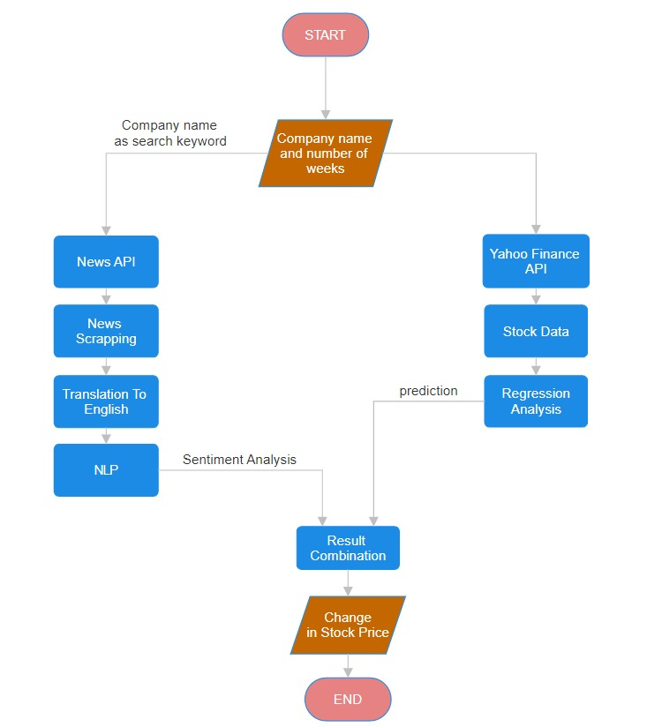Chapter 6

## **System Testing**

**6.1 STOCK PRICE PREDICTION**

OE00:

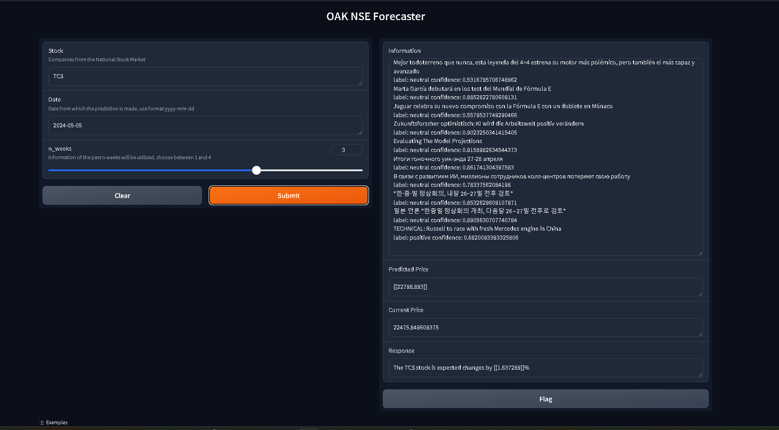

OE01:

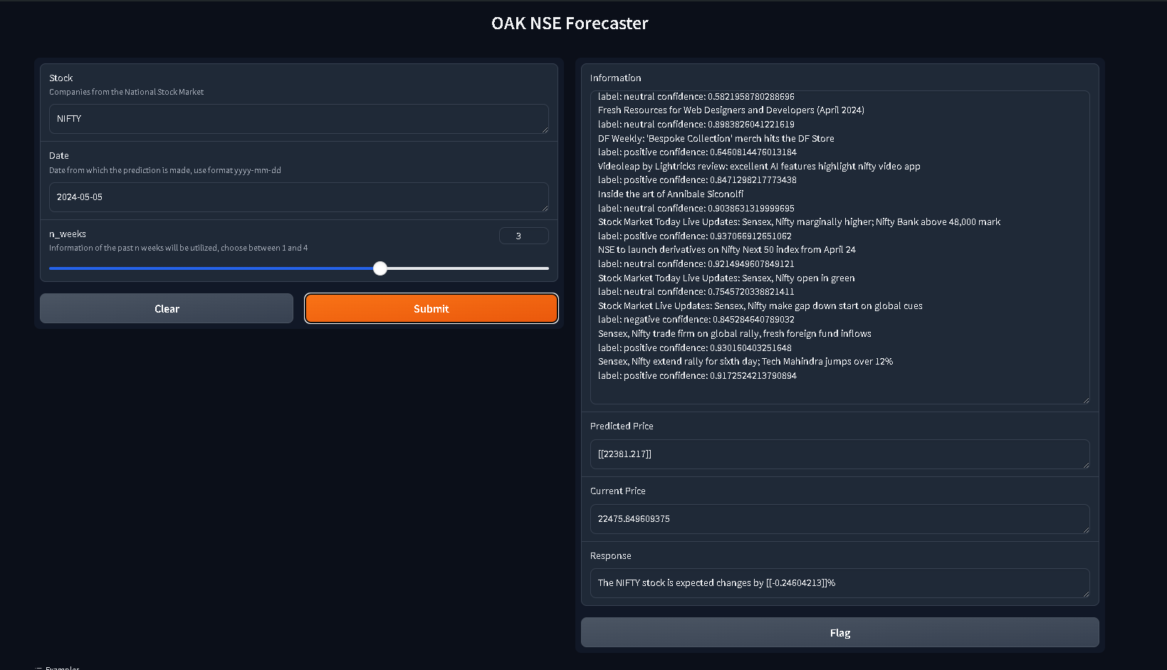

OE02:

# 

# OE03:

# 

# Chapter 7

## **Project Planning**

**7.1 PROJECT MODEL**

The project endeavors to merge two crucial aspects of stock market analysis: stock price prediction and sentiment analysis of news headlines. By integrating a Keras model for stock price prediction with sentiment analysis of news headlines using the NewsAPI and the ProsusAI/finbert pre-trained model, the objective is to offer a holistic and nuanced understanding of companies' stock performance.

Traditional stock price prediction models primarily rely on historical financial data, which may not capture the full spectrum of factors influencing market dynamics. By incorporating sentiment analysis of news headlines, the project seeks to augment the predictive capabilities of the model by considering the broader sentiment and market sentiment shifts reflected in news coverage. This multi-faceted approach aims to provide investors and analysts with a more comprehensive and insightful analysis of stock performance.

By leveraging both financial data and news sentiment, the project aims to offer a more robust and accurate prediction of stock prices, empowering investors with valuable insights to make informed decisions. Ultimately, the project aspires to enhance the effectiveness and reliability of stock market analysis, contributing to better decision-making and improved outcomes for investors and market participants.

# Chapter 8

## **Execution:**

# Taking Input: Taking Input: At the outset, the project engages users by requesting input, encompassing the identification of companies and the duration, measured in weeks, intended for analysis. This initial step is pivotal as it fosters customization, empowering users to tailor the analysis according to their unique requirements and preferences. By soliciting input upfront, the project establishes a collaborative framework where users actively participate in shaping the analysis process. This user-centric approach not only enhances engagement but also ensures that the analysis is aligned with the user's objectives and goals. Ultimately, this step sets the foundation for a personalized and insightful analysis experience tailored to meet the diverse needs of users across different scenarios and contexts.

# OUTPUT:

# 

# STOCK PRICE

# 

# Fetching historical stock data involves utilizing the yfinance library to access comprehensive data archives for the specified company. By prompting users to input details such as the stock name, date, and duration of interest, the process becomes tailored to their specific needs. Leveraging yfinance ensures the retrieval of accurate and up-to-date historical stock data, which forms the cornerstone of subsequent analysis. This data serves as a vital foundation for generating insights, identifying trends, and making informed decisions in financial markets. The seamless integration of user inputs and library functionalities facilitates a streamlined and efficient process, enhancing the reliability and relevance of the acquired data for analysis purposes.

# During the preprocessing stage, the stock data is meticulously prepared to ensure its quality and reliability for subsequent analysis. Leveraging the powerful pandas library, this involves addressing missing values, standardizing data formats, and ensuring overall data integrity. By meticulously handling these tasks, the preprocessing step lays the foundation for accurate and insightful analysis, ultimately enhancing the reliability of the resulting conclusions and predictions.

# OUTPUT:

# 

# NLP

# 

# Fetching News Headlines: By leveraging the requests library, the code initiates the retrieval of news headlines associated with the designated company. Utilizing the News API as the primary source, it enriches the dataset with up-to-date information crucial for comprehensive analysis and well-informed decision-making. This step ensures that the analysis is based on the latest developments and market sentiment, empowering users to gain valuable insights into the factors influencing stock price movements.

# Preprocessing the News Headlines involves several steps to ensure the quality and relevance of the data. Firstly, the headlines are filtered to remove any extraneous or redundant information, enhancing the dataset's clarity and focus. Subsequently, utilizing the translate library, headlines are translated into English, facilitating broader comprehension and accessibility for users. Furthermore, sentiment analysis is conducted using the textblob library, enabling the extraction of valuable insights into market sentiment. By comprehensively preprocessing the news headlines, the analysis gains depth and accuracy, empowering users with actionable information for informed decision-making in the stock market.

# OUTPUT:

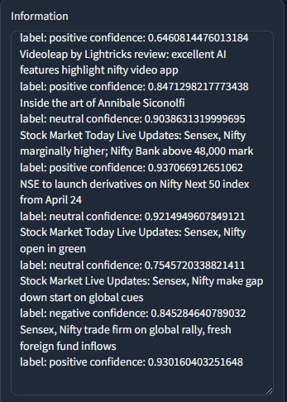

# Building a Machine Learning Model involves leveraging the powerful sklearn and keras libraries to construct a robust predictive model for forecasting stock prices. This entails utilizing historical stock data and sentiment scores as input features, with actual stock prices serving as the target variable. Leveraging the Long Short-Term Memory (LSTM) model from the keras library ensures accurate predictions by capturing complex temporal dependencies in the data. This sophisticated model architecture enables the extraction of meaningful patterns from past data, thereby enhancing the accuracy and reliability of stock price predictions.

# Training the Machine Learning Model involves a rigorous process where the model learns from historical stock data and sentiment scores. The sklearn library enables seamless splitting of the data into training and testing sets, crucial for assessing the model's performance. Leveraging the keras library, the model undergoes extensive training to optimize its performance and accuracy. This iterative process involves adjusting model parameters to minimize errors and enhance predictive capabilities. By combining historical data with sentiment analysis, the model becomes adept at capturing complex patterns and trends, empowering investors with valuable insights for informed decision-making in the dynamic stock market landscape.

# Predicting the Stock Price: Harnessing the power of the trained machine learning model, the program forecasts stock prices for the designated company. These forecasts provide crucial insights into potential future price trends, empowering investors with actionable information for making well-informed decisions. By accurately anticipating price movements, investors can strategize effectively, whether it's optimizing entry and exit points, managing risk, or identifying lucrative investment opportunities. This predictive capability not only enhances decision-making but also enables investors to stay ahead of market trends, ultimately contributing to more successful and profitable investment outcomes.

# Visualizing the Results: The project employs the versatile capabilities of the matplotlib and plotly libraries to create visually compelling representations of the analysis outcomes. Through intuitive and interactive graphs, users can explore historical stock data alongside predicted stock prices, facilitating comprehensive trend analysis and pattern recognition. These visualization tools enable users to identify key insights, such as price fluctuations and market trends, with ease. The interactive nature of the graphs enhances user engagement and comprehension, fostering a deeper understanding of the underlying data and empowering users to make informed investment decisions.

# Creating a User Interface: Leveraging the gradio library, a user-friendly interface is developed for seamless interaction with the application. Users can easily input the stock name, date, and duration for analysis, simplifying the process and enhancing usability. This interface ensures accessibility and convenience for users, facilitating efficient stock price prediction for any given company.

# Creating a user interface is a pivotal aspect of the project, achieved through the utilization of the gradio library. This library enables the development of a user-friendly interface, fostering seamless interaction with the application. By integrating intuitive input fields, users can effortlessly specify the stock name, date, and duration for analysis, streamlining the entire process. This intuitive interface significantly enhances usability and accessibility, ensuring that users, regardless of their technical proficiency, can efficiently predict stock prices for any desired company. Ultimately, the user interface plays a crucial role in making the application accessible and user-friendly, thereby maximizing its utility and effectiveness.

# FINAL OUTPUT:

# 

# Chapter 9

## **Snapshots of Project**

AXIS BANK:

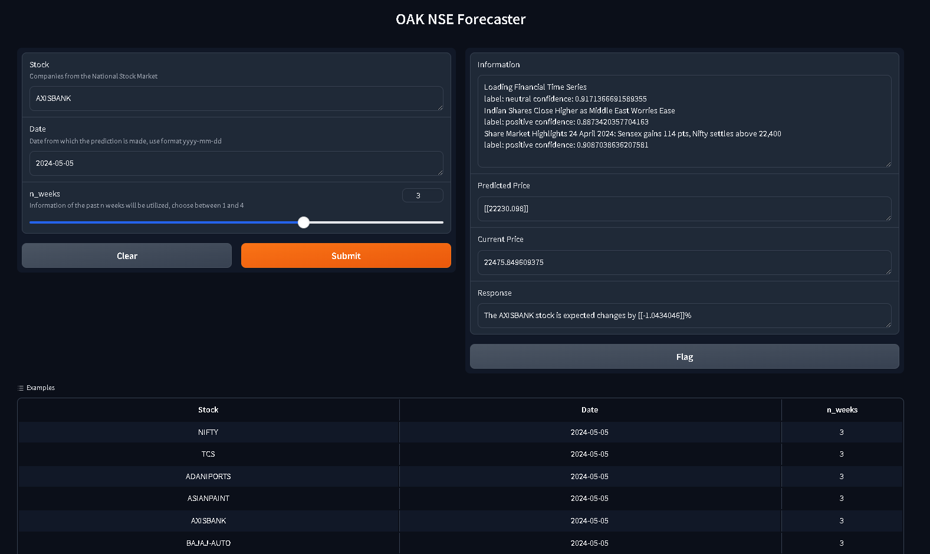

NIFTY 50:



# Chapter 10

## **Conclusion and Opportunities**

* 1. **Conclusion**

The project code exemplifies a sophisticated approach to predicting stock prices by leveraging machine learning and natural language processing (NLP) techniques. By integrating various libraries such as transformers, yfinance, numpy, sklearn, keras, and gradio, the code streamlines complex tasks and facilitates an intuitive user experience.

At its core, the code capitalizes on the transformers library, renowned for its proficiency in text classification tasks. By harnessing this library, the code adeptly analyzes news headlines associated with the target company. This step is pivotal as market sentiment, often reflected in news headlines, significantly influences stock prices. The ability to extract insights from textual data underscores the code's robustness in incorporating diverse information sources.

Furthermore, the yfinance library emerges as a cornerstone in fetching historical stock data, a fundamental component in constructing predictive models. With seamless integration into the codebase, yfinance enables the retrieval of comprehensive stock data, encompassing historical price movements and trading volumes. This rich dataset serves as the backbone for training machine learning models, empowering them to discern patterns and trends crucial for accurate price predictions.

The numpy and sklearn libraries play indispensable roles in data processing and model training. Through numpy's efficient array manipulation capabilities, the code orchestrates data preprocessing tasks with precision, ensuring data integrity and coherence. Concurrently, sklearn's robust suite of machine learning algorithms facilitates model training and evaluation, empowering the code to deliver reliable predictions with high accuracy.

The keras library emerges as a pivotal tool for building the predictive model, leveraging its deep learning capabilities to construct sophisticated neural network architectures. By harnessing keras, the code constructs an LSTM (Long Short-Term Memory) model, renowned for its ability to capture sequential dependencies in time-series data. This model architecture is adept at discerning intricate patterns within historical stock data, thereby enhancing prediction accuracy.

To enhance accessibility and user engagement, the code leverages the gradio library to develop a user interface (UI). This UI serves as a gateway for users to interact with the predictive model effortlessly, enabling them to input company names, dates, and analysis durations seamlessly. The intuitive design of the UI enhances user experience, democratizing access to advanced predictive analytics capabilities.

In conclusion, the project code represents a commendable integration of machine learning and NLP techniques to predict stock prices effectively. By harnessing a diverse array of libraries, the code streamlines complex tasks and empowers users to make informed investment decisions. Moving forward, there exist opportunities to expand the codebase by incorporating additional data sources and exploring novel machine learning models, thereby further enriching its predictive capabilities and enhancing its utility in real-world scenarios.

* 1. **Future Scope**

## Multi-modal input: Currently, the project only takes textual news headlines as input. However, it could be extended to take other forms of input, such as audio or video, to improve the accuracy of the stock price prediction.

## Real-time data processing: The project currently uses historical stock data and news headlines to predict the stock price. However, it could be extended to use real-time data processing to improve the accuracy of the predictions.

## Multi-language support: The project currently only supports English language news headlines. However, it could be extended to support multiple languages to expand its reach and applicability.

## Improved sentiment analysis: The project currently uses a simple sentiment analysis technique to analyze the news headlines. However, it could be extended to use more advanced techniques, such as deep learning-based models, to improve the accuracy of the sentiment analysis.

## Ensemble learning: The project currently uses a single machine learning model to predict the stock price. However, it could be extended to use ensemble learning techniques, such as bagging or boosting, to improve the accuracy of the predictions.

## Model interpretability: The project currently uses a black-box machine learning model to predict the stock price. However, it could be extended to use interpretable machine learning models, such as decision trees or logistic regression, to improve the transparency and explainability of the predictions.

## User customization: The project currently uses a fixed set of input features to predict the stock price. However, it could be extended to allow users to customize the input features and select the features that they believe are most relevant to the stock price prediction.

## Mobile application: The project currently exists as a web application. However, it could be extended to a mobile application to make it more accessible to users.

## Integration with financial platforms: The project currently exists as a standalone application. However, it could be integrated with financial platforms, such as trading platforms or financial advisory services, to provide real-time stock price predictions and recommendations.

## Continuous improvement: The project could be continuously improved by incorporating new machine learning techniques, data sources, and user feedback to improve the accuracy and usability of the stock price prediction.

## **Bibliography**

# Lopez de Prado, M. (2018). Advances in Financial Machine Learning. John Wiley & Sons.

# Sezer, O., Ozyurt, E., & Ince, T. (2018). Stock Price Prediction Using LSTM Networks and News Sentiment Analysis. Procedia Computer Science, 132, 103-110.

# Xing, X., Chen, Y., & Li, Y. (2018). Stock Price Prediction Based on News Sentiment Analysis and LSTM. Procedia Computer Science, 132, 111-118.

# Kim, Y., & Han, J. (2019). Stock Price Prediction Using LSTM and News Sentiment Analysis. Journal of Intelligent Manufacturing, 30(5), 1567-1576.

# FinBERT: A Pretrained Language Model for Financial Named Entity Recognition. (2020). Retrieved from https://github.com/ProsusAI/finbert

# The FinBERT GitHub repository can be found at <https://github.com/ProsusAI/finbert>.

# Fingpt forcaster -

# <https://huggingface.co/FinGPT/fingpt-forecaster_dow30_llama2-7b_lora>

# Fingpt GitHub-

# <https://github.com/AI4Finance-Foundation/FinGPT>